**HEART ARRHYTHMIAS**

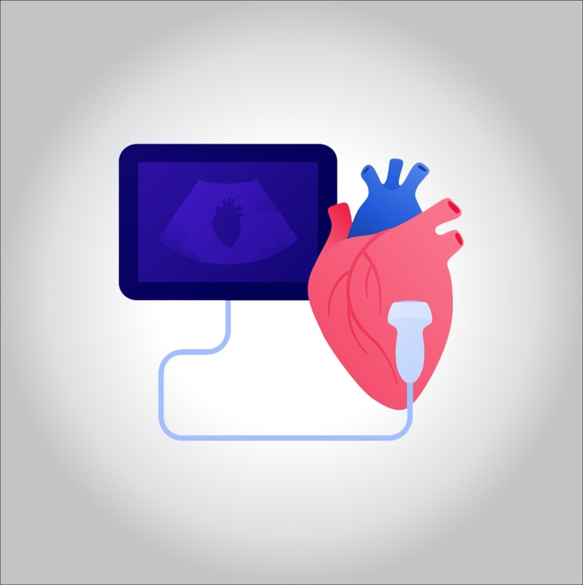

**Heart rhythm problems (heart arrhythmias) occur when the electrical impulses that coordinate your heartbeats don’t work properly, causing your heart to beat too fast, too slow or irregularly.**

**Heart arrhythmias may feel like a fluttering or racing heart and may be harmless. However, some heart arrhythmias may cause bothersome — sometimes even life-threatening — signs and symptoms.**

**Heart arrhythmia treatment can often control or eliminate fast, slow or irregular heartbeats. In addition, because troublesome heart arrhythmias are often made worse — or are even caused — by a weak or damaged heart, you may be able to reduce your arrhythmia risk by adopting a heart-healthy lifestyle.**

**What are the symptoms?**

* **A fluttering in your chest**
* **A racing heartbeat (tachycardia)**
* **A slow heartbeat (bradycardia)**
* **Chest pain**
* **Shortness of breath**
* **Anxiety**
* **Fatigue**
* **Lightheadedness or dizziness**
* **Sweating**
* **Fainting or near fainting**

**What are the causes?**

**Certain conditions can lead to, or cause, an arrhythmia, including:**

* **A heart attack that’s occurring right now**
* **Scarring of heart tissue from a prior heart attack**
* **Changes to your heart’s structure, such as from cardiomyopathy**
* **Blocked arteries in your heart (coronary artery disease)**
* **High blood pressure**
* **Overactive thyroid gland (hyperthyroidism)**
* **Underactive thyroid gland (hypothyroidism)**
* **Diabetes**
* **Sleep apnea**

**Other things that can cause an arrhythmia include:**

* **Smoking**
* **Drinking too much alcohol or caffeine**
* **Drug abuse**
* **Stress or anxiety**
* **Certain medications and supplements, including over-the-counter cold and allergy drugs and nutritional supplements**
* **Genetics**

**Risk factors**

* **Coronary artery disease, other heart problems and previous heart surgery**
* **High blood pressure**
* **Congenital heart disease**
* **Thyroid problems**
* **Diabetes**
* **Obstructive sleep apnea**
* **Electrolyte imbalance**

**Prevention**

* **Eating a heart-healthy diet**
* **Staying physically active and keeping a healthy weight**
* **Avoiding smoking**
* **Limiting or avoiding caffeine and alcohol**
* **Reducing stress, as intense stress and anger can cause heart rhythm problems**
* **Using over-the-counter medications with caution, as some cold and cough medications contain stimulants that may trigger a rapid heartbeat**

**Treating fast heartbeats**

* **Vagal maneuvers.**
* **Medications.**
* **Cardioversion.**
* **Catheter ablation.**